EC2 Scheduler with API Gateway

## Step by Step Implementation

### Creating REST API

Go to API Gateway > Create API > choose REST API

Give your API a name and description. Leave the Endpoint type as Regional and create your API.

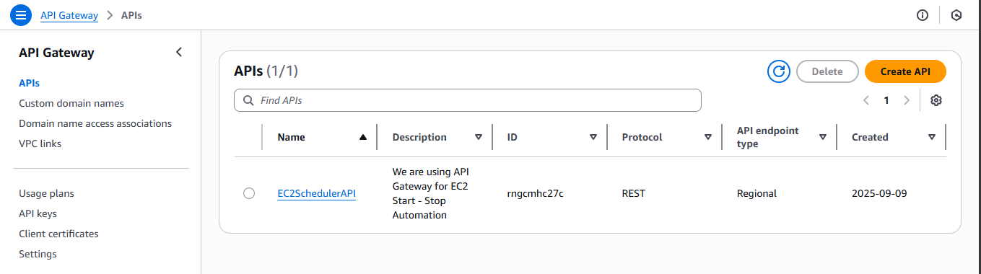

### Create a Start/Stop Endpoint

Here, Click on the EC2SchedulerAPI, and then click on Create Resource.

* Resource Name: StartEC2 > Resource Path: /StartEC2
* Select /start - Create Method > choose POST.
* Configure - Integration type: Lambda Function. Choose your Lambda function. Click Save.

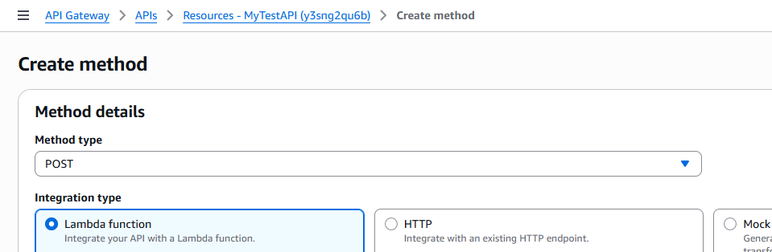

* On the Method Execution page, click Integration Request > expand Mapping Templates > Add mapping template > Content-Type: application/json.
* Paste this JSON mapping:  
   {

"action": "start"

}

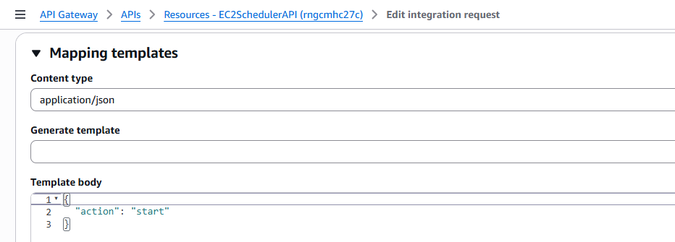

Follow similar steps for Stop Endpoint.

* Resource Name : StopEC2 > Resource Path: /StopEC2
* Paste this JSON mapping:  
   {

"action": "stop"

}

The Resources should look like this -

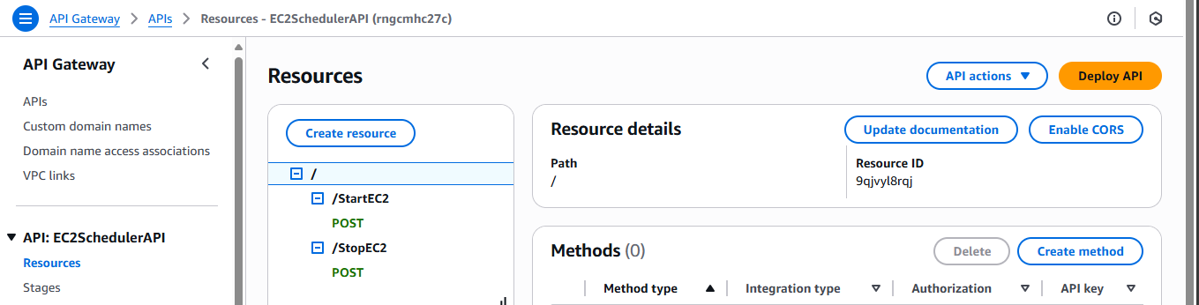

### Deploy the API

* With the POST method selected, click Deploy API.
* Deployment stage - New Stage and Name: dev / test / prod

I have named it ‘prod’.

* Note the Invoke URL, which looks like:

<https://rngcmhc27c.execute-api.ap-south-1.amazonaws.com/prod/StartEC2>

<https://rngcmhc27c.execute-api.ap-south-1.amazonaws.com/prod/StopEC2>

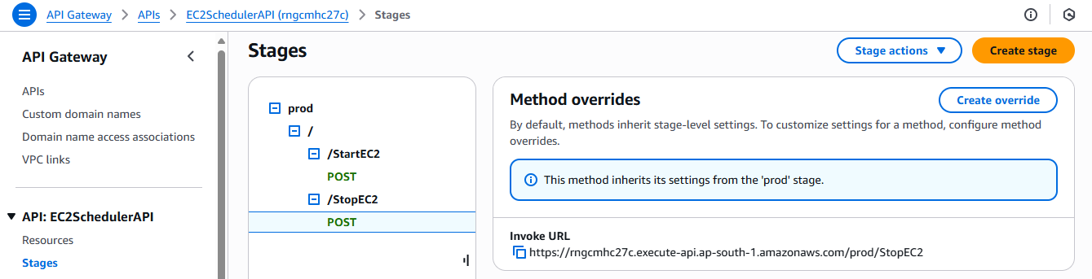

### Testing using and Postman API Gateway Console

**Open Postman**.

Click New > HTTP Request. In the request bar select Method - POST and paste the /startEC2 URL.

Go to the Body tab and choose raw and JSON.

Since we configured fixed mapping, leave the body empty.

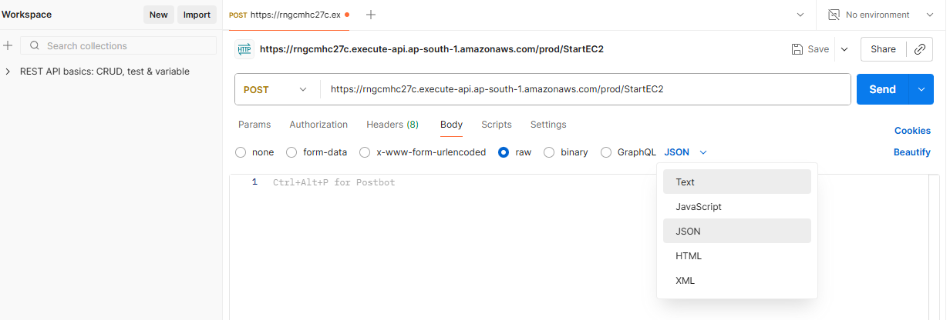

Expected Response -

Response code: 200

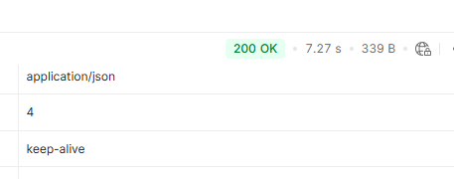

The instance started and SNS email has been received -

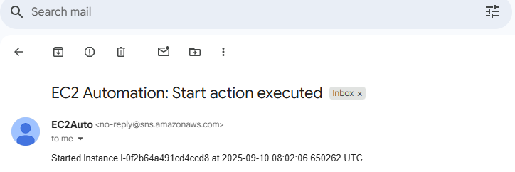

As we have tested our API using postman, we can also test it using API Gateway Console.

I am testing it for /StopEC2.

Select your POST method for /StopEC2 > scroll down and click Test ( next to Method Respond ) > leave everything empty > click Test button.

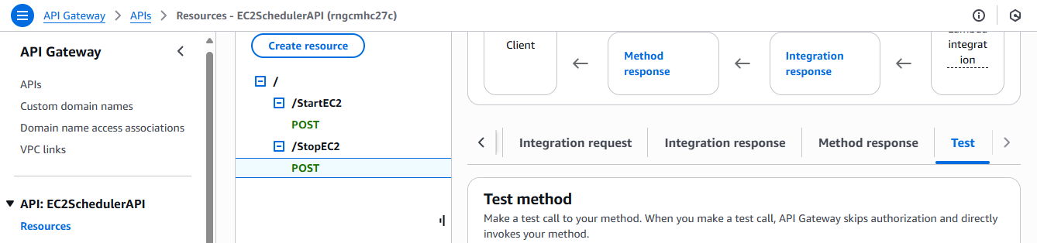

Results are -

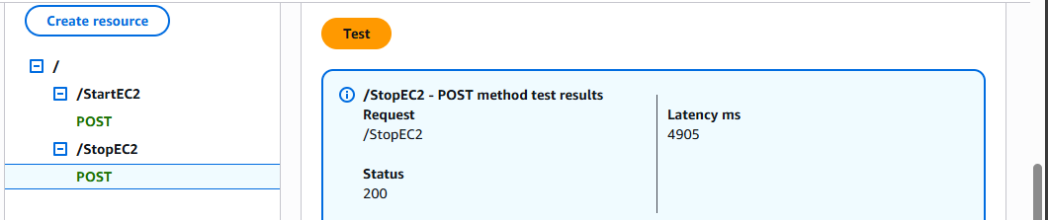

The instance stopped and SNS email has been received -

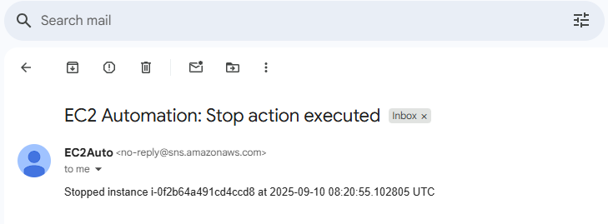

### Eventbridge Rules

* Go to Amazon EventBridge > Rules > Create rule. Rule name: StartEC2RuleAPI  
  Choose Schedule > Recurring schedule.  
  Select Cron expression and enter the desired time.

I have entered - 35 11 * * ? *

* Now, In Target, choose: API Gateway → API endpoint  
  Select your API (EC2SchedulerAPI)  
  Stage: prod  
  Method: POST Resource path: /StartEC2 Save rule.
* Similarly Create rule for /StopEC2.

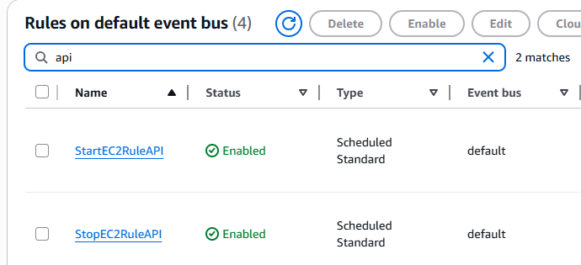

### Results

As we can see, the EC2 instance now starts and stops at the scheduled times, and the email notifications are triggered as expected.



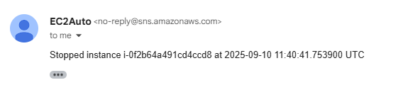

### Conclusion

This project successfully automates EC2 instance management by combining Lambda, EventBridge, API Gateway, and SNS. The instance now starts and stops automatically at scheduled times, while API Gateway endpoints provide flexibility for manual control, and email notifications ensure visibility of every action.